

Report on survey of financial literacy

February to June 2012

Prepared by the New Zealand Education Institute for the Commission for Financial Literacy and Retirement Income



Contents

Overview 3

The need 3

Provision of financial literacy programmes 3

Lack of professional development opportunities 4

Introduction 5

Overall findings 5

Methodology 6

Findings 8

Financial literacy programmes 8

Decile 9

Sample 9

Auckland 9

Nelson 9

School size (U-grade) 10

Sample 10

Auckland 10

Nelson 11

Schools that offer financial literacy 12

Types of financial literacy 12

Timespan of programme 13

Internally or externally provided programmes 14

School-wide or targeted programmes 15

Stand-alone or cross-curricular programmes 15

Professional development received 16

Schools that do not offer financial literacy 17

Barriers to financial literacy programmes 17

Interest in learning more 18

In-depth survey responses 19

Surveys 21

Telephone survey 21

In-depth survey 23

Telephone survey responses 26

# Overview

The Schools Advisory Group to The Commission of Financial Literacy and Retirement Income commissioned NZEI to survey primary teachers on the implementation of financial literacy programmes within their schools. The purpose of the survey was to establish some baseline data about financial literacy provision in New Zealand primary schools so that growth over time can be measured.

This report presents the findings of the telephone survey undertaken in the Auckland and Nelson regions between February and May 2012. The limitations of the small sample size mean the findings from the survey can be seen as a snapshot relative to the two regions rather than indicative of what is occurring across New Zealand.

## The need

In today’s society there is an imperative for young people to be financially literate. Young people need to be educated so as to be able to operate and achieve personal financial wellbeing in an environment which demands financial knowledge.

“Financial products such as insurances, credit cards and hire purchase agreements are becoming more complex. And young people are doing more and more transactions with cards rather than handling notes and coins. They do not see or touch money coming in and going out, which tends to distance them from their own financial situation.” (Wood 2012)[1]

The New Zealand Curriculum[2] encourages teachers to explore the links between learning areas by designing units of work or broad programmes to “develop students’ financial capability, positioning them to make well-informed financial decisions throughout their lives” (p39).

The NZEI survey collected primary teachers’ and principals’ perspectives on what financial literacy programmes were being offered in schools and the types of programmes, as well as exploring why some schools did not offer financial literacy.

## Provision of financial literacy programmes

The findings of the survey show that today, five years after financial literacy was included in the New Zealand Curriculum, almost half the schools surveyed offered financial literacy programmes. The finding was typical regardless of the size or type of school or whether the school was in Auckland or Nelson, but schools in high socio-economic areas were more likely to offer financial education. The type of financial literacy programme identified by the largest number of schools was run by or in conjunction with a bank.

The schools surveyed which offered financial literacy programmes used an equal number of internal and external programmes. Of those schools using external programmes, most offered a “programme from a bank” (e.g. ASB Bank), followed by the use of the Ministry of Education’s *Figure It Out* resource booklets. Most financial literacy programmes had a short to medium timespan.

For those teachers who had professional learning and development opportunities, the most common forms were run by an external agency, for example, a bank.

## Lack of professional development opportunities

The vast majority of teachers responding to the survey had no professional learning opportunities in relation to financial literacy.

A lack of understanding of, and exposure to, what financial literacy comprises is reflected by teachers in schools that did not offer financial literacy, with the most common barriers being “not enough time”, “overloaded curriculum”, “lack of professional development and expertise”. Some schools believed that financial literacy was too advanced for their students. This latter perception confirms research showing that Māori and Pacific island people are more likely to be among the low knowledge group.

If the goal of all primary students being financially capable is to be achieved then opportunities for teachers’ professional growth in financial literacy must be treated seriously and with urgency.

# Introduction

The Financial Education Schools Advisory Group to the Commission of Financial Literacy and Retirement Income commissioned NZEI Te Riu Roa to survey NZEI members regarding financial literacy programmes within their schools. A telephone survey was undertaken with 134 NZEI Worksite Representatives[3] from different schools within the Auckland/Northland and Nelson/Tasman regions. Schools that provided financial literacy programmes were encouraged to complete a further in-depth survey via email, to which four responses were received. The surveys were undertaken between February and May 2012.

This report states the overall findings of the survey before providing analysis of each survey question in more depth. A copy of the survey is included near the end of the report, as well as the raw data collected from the surveys.

Due to the sample size, findings reported should not be seen as indicative – they provide a snapshot from a small sample size in two areas of New Zealand.

## Overall findings

The overall findings were as follows:

* Forty-six per cent of schools offered financial literacy programmes. The type of financial literacy programme identified by the largest number of schools was run by or in conjunction with a bank.
* Responses to many of the survey questions show there is no obvious discrepancy between schools located in Auckland/Northland and Nelson/Tasman regions.
* There is a higher likelihood that financial literacy programmes are run in schools with higher socio-economic status, as measured by decile rankings 7, 8 and 9.
* School roll size (U-grade) appears to have no significant relationship to the financial literacy programmes on offer.

Of those schools that offer financial literacy:

* The majority of schools offer a “programme from a bank” facilitated by bank staff (e.g. ASB Bank), followed by the use of *Figure It Out* resource books produced by the Ministry of Education, and a “separate unit of study within the school that focuses on financial literacy”.
* Of those schools delivering financial literacy using a bank as provider, 70% offer only this programme.
* Most programmes have a short (one-off to two weeks) to medium (two weeks to one term) timespan.
* There are equal numbers of internally and externally provided programmes.
* Seventy per cent of programmes are school wide while 30% are targeted to a specific group, most often in the senior school.
* There are equal numbers of stand-alone and cross-curricular programmes. Cross-curricular programmes included money programmes in maths, Consumer Guarantees Act in social studies and play shops.
* The majority of respondents (55%) have not received professional development for financial literacy. Of those who had, the most common forms of professional development were a “programme run by an external agency” (e.g. ASB Bank), and as “part of broader numeracy programmes in schools or social studies professional development”.

Of those schools that did not offer financial literacy:

* The most common barriers to providing a financial literacy programme were “not enough time”, “overloaded curriculum” and “lack of professional development and expertise”.
* Two-thirds of schools not offering financial literacy programmes said it was not considered or discussed.
* Slightly less than 10% felt it was too advanced for deciles 1 and 2 students.
* One-third of respondents were interested in learning more about financial literacy programmes. These respondents were given the contact details of The Commission of Financial Literacy and Retirement Income for further information and directed to the resources available on the financialliteracy.org.nz website.[4]

## Methodology

Telephone surveys were completed with 134 schools, of which 4 responded to the more detailed survey. Respondents were NZEI worksite representatives who were teachers. The regional split was 103 surveys from the Auckland/Northland region and 31 from the Nelson/Tasman region. A random sample of schools in these areas was taken from the NZEI membership database. The random selection was based on location (a mix of urban and provincial schools) and then data was analysed against the variables of size of school (using U-grade) and the socio-economic status (based on decile ranking).

The completion of 134 surveys required 335 calls to be made. Two attempts to contact each worksite representative were made before moving to the next selection.

The telephone surveys were completed by a team of five NZEI staff members in the Organising Call Centre (OCC). The Organising Call Centre is an outbound call centre staffed by students, operating from 5pm–8.30pm Monday to Thursday and Sunday 10am–5pm. All surveys were completed during evening calls on week nights due to the length of the call. Each completed survey took between 15 and 25 minutes depending on the amount of information the worksite representative was able to provide. The financial literacy call programme was one of several operating at the same time, so not all staff worked solely on this programme at all times.

The survey questions were designed following several meetings between Pushpa Wood (Commission for Financial Literacy and Retirement Income), Sandra Aikin (NZEI Te Riu Roa Senior Officer – Professional, and staff representative on the Advisory Group) and Shelley Hughes (NZEI Te Riu Roa staff member responsible for the OCC). Background material to support the call programme was supplied by Pushpa Wood, and the call centre staff received training to provide a level of understanding that would allow engagement in conversation with the survey participants.

Survey responses were collated using Survey Monkey, and call centre staff analysed the results.

# Findings

## Financial literacy programmes

Overall, the survey responses indicate there are slightly more schools that do not offer financial literacy programmes than do.

Despite the significantly smaller sample size from Nelson, both Nelson (n= 31) and Auckland (n=103) have similar results reflecting the overall pattern of provision of financial literacy programmes.



 

## Decile

### Sample

The number of schools surveyed ensured coverage of each decile category, with numbers ranging from 9 schools at deciles 6 and 9, up to 19 schools at decile 10. Overall it appears that deciles 7, 8 and 9 are more likely to offer financial literacy programmes.

Results are likely to be skewed due to the sample size.

### Auckland

The sample for Auckland had an even range but deciles 1 and 10 were peaks of this data sample with more survey respondents. Auckland showed that deciles 7, 8 and 9 were more likely to offer financial literacy.

### Nelson

This sample had a roughly even range, although the data peaked on decile 7. There were no decile 1 schools taken in the sample. Deciles 5 and 9 were the most likely to offer financial literacy programmes and decile 3 was the least likely.





## School size (U-grade)

The size of the school is reflected by U-grade, as shown in the table below.

|  |  |
| --- | --- |
| U-Grade | Roll size |
| 1 | 1–50 |
| 2 | 51–100 |
| 3 | 101–150 |
| 4 | 151–300 |
| 5 | 301–500 |
| 6 | 501–675 |
| 7 | 676–850 |
| 8 | 851–1025 |
| 9 | 1026–1200 |

Sample

The sample data peaked at the 4 to 6 U-grade range (151–675 students); this is likely to reflect the average roll size of primary schools in New Zealand. The school size offered no significant correlation as to whether or not schools offered financial literacy.

Auckland

Auckland followed the same trend as the total sample, where the school size offered no significant correlation with the provision of financial literacy programmes.

Nelson

The range of the U-grade in the Nelson was 1 to 6; this is likely due to Nelson having a smaller population than Auckland. As with the sample trend the U-grade offered no significant correlation as to whether or not Nelson schools offered financial literacy.





Schools that offer financial literacy

### Types of financial literacy

The type of financial literacy programme identified by the largest number of schools was run by or in conjunction with a bank, most notably ASB Bank or National Bank. Programmes based on *Figure It Out* booklets and programmes integrated into the wider curriculum were also widespread. Separate units were identified by slightly more schools than programmes integrated into the curriculum and hands-on activities.



Financial literacy programmes offered through banks are externally provided programmes facilitated by banking staff, predominately with ASB Bank or National Bank.

*Figure It Out* workbooks are books that provide support to the NZ mathematics curriculum. These were the preferred option of many schools who participated in the survey.

Fourteen schools integrated financial literacy activities into the curriculum and did not include use of the *Figure It Out* workbooks. Examples include money programmes in mathematics, Consumer Guarantees Act in social studies and play shops.

Several schools deliver financial literacy using hands-on, practical activities within the regular school event cycle. Examples include gala days, market days and fundraising opportunities.

Included in the separate units offered by some schools are activities outside of the usual curriculum for a select group of students. Examples include Enterprise and PrEP programmes.

Of those schools delivering financial literacy using a bank as provider, 70% offer only this programme and 30% supplement this with other programmes.

Some schools offered multiple financial literacy programmes, e.g. *Figure It Out* books by themselves and integrated into the curriculum for other subjects such as social studies.

### **Timespan of programme**

Programmes identified by schools are run for varying amounts of time, ranging from a single one-off session to in-depth courses run over multiple terms. Most schools run programmes with short to medium timespans (often schools running programmes facilitated by outside providers), with only a minority of schools identifying a long-term financial literacy programme.

A short timespan is a one-off session, or a programme that would last a maximum of a fortnight. Examples include ASB Bank sessions and market days.

A medium timespan is a programme that ranges in length from a fortnight to a school term. Examples include Enterprise and PrEP programmes, *Figure It Out* workbooks and planning for school galas.

A long timespan is any programme that lasts longer than a school term. Examples include programmes integrated into the curriculum and running school lunch programmes.



The graph shows the results per programme rather than per school, as some schools ran multiple programmes that differed in timespan.

### Internally or externally provided programmes

Schools were fairly evenly divided in the use of externally or internally developed and provided programmes. Slightly more schools ran an internally provided programme.



External programmes are run by people and organisations outside of the school and tend to be provided by the banks, in particular ASB Bank.

Internal programmes are run by teachers and staff of the school and are often integrated into the curriculum or with school events.

### School-wide or targeted programmes

Around two-thirds of schools running Financial Literacy Programmes do so school wide. The remaining third target their programmes towards certain groups of students, most often in the senior school.



### Stand-alone or cross-curricular programmes

Schools running financial literacy programmes were evenly split between running stand-alone programmes, or covering financial literacy as part of their wider curriculum across several areas, e.g. maths and social studies.



### Professional development received

The vast majority of schools providing financial literacy programmes did not offer any professional learning and development support, or provided only what was required to help implement the programme provided by outside agencies.

A minority of schools had provided some staff with professional development and a similar number were planning to do so in the future. Some schools provided professional development as part of their general numeracy or social studies development.



## Schools that do not offer financial literacy

### Barriers to financial literacy programmes

Most schools that do not offer a financial literacy programme identified several barriers to doing so. The main reasons identified were the interrelated problems of a lack of time and an overloaded curriculum, with 70% of survey respondents identifying these as the cause. The next largest barrier identified was the lack of professional development and expertise for staff. A notable number identified the lack of resources as a barrier to financial literacy programmes. Some schools cited a lack of interest in financial literacy programmes or considered them a low priority. Other barriers noted by schools included two low decile schools not feeling that their students were strong enough at basic maths, and another that had carried out a survey with parents in which financial literacy was ranked a low priority.



### Interest in learning more

When asked, nearly a third of schools not offering financial literacy programmes were interested in learning more. Of the two-thirds of schools who were not interested, almost 10% said that it had never been considered or discussed and a further 10% felt financial literacy was too advanced for primary-aged children. Most of the schools who felt it was too advanced were decile 1 or 2. Some respondents declined to answer as they were not in a position to implement a programme within their school.



# In-depth survey responses

The respondents taught financial literacy to students between year 3 and year 8. Student numbers ranged from 15 to 96 per year level, with the largest proportion of students being in year 5 and year 6.

The number of hours involved in providing financial literacy programmes varied from 1 hour to 30 hours. The number of hours peaks at years 5 and 6. One respondent provides a consistent one hour per school term.

None of the respondents had received teacher learning and professional development (PLD) in financial literacy in 2011.

In previous years, one respondent stated they received financial literacy PLD at a course held off-site by a private company.

Two respondents had formal processes for assessing student achievement in financial literacy. These were embedded in numeracy assessment and a standard formative assessment.

The key resources used for teaching financial literacy included “resources from the internet” and “resources from the bank/s”. Other less common resources included the “Ministry of Education TKI website”, “FIO resources” and “Futureintech”.

Although most respondents would like to have access to more resources, there was no consistency across respondents regarding what they would like these resources to be. Some examples given included “a Ministry of Education-funded provider”, “a private company”, “a community organisation”, “an individual consultant”, “a Sorted facilitator”, “good FIO resources” and “more online resources”.

Likewise, most respondents would like access to additional PLD. Examples include a “staff meeting allocation with expert or outside resource person” and “any PLD that is on offer”.

The following table displays the results of the in-depth survey emailed to members. Four responses were received.

|  |  |  |  |  |  |
| --- | --- | --- | --- | --- | --- |
| Question | | Respondent 1 | Respondent 2 | Respondent 3 | Respondent 4 |
| Number of students involved in financial literacy | Year 1 |  |  |  |  |
| Year 2 |  |  |  |  |
| Year 3 | 50 | 32 |  |  |
| Year 4 | 60 | 36 |  |  |
| Year 5 | 60 | 77 | 40 | 60 |
| Year 6 | 60 | 96 | 40 | 30 |
| Year 7 |  | 53 | 30 | 15 |
| Year 8 |  | 48 | 30 | 15 |
| Number of hours involved in providing financial literacy | Year 1 |  |  |  |  |
| Year 2 |  |  |  |  |
| Year 3 | 10 | 1 |  |  |
| Year 4 | 10 | 1 |  |  |
| Year 5 | 30 | 3 | 1 hour per week for a term | 8 |
| Year 6 | 30 | 3 | 1 hour per week for a term | 8 |
| Year 7 |  | 2 | 1 hour per week for a term | 10 |
| Year 8 |  | 2 | 1 hour per week for a term | 10 |
| Total number of PLD on financial literacy received by the school in 2011 | | None | None | None | None |
| How the PLD was delivered | |  |  | At a course off-site |  |
| PLD provider | |  | A private company |  |  |
| Formal processes for assessing student achievement in financial literacy | | Embedded in numeracy assessment |  |  | Standard formative assessment |
| Resources used to teach financial literacy | | Resources from internet, Futureintech | Resources from internet, from the bank/s | From the bank/s | Ministry of Education TKI website, FIO resources |
| Additional resources they would like to have access to | | A Ministry of Education-funded provider  A private company  A community organisation  An individual consultant  A Sorted facilitator |  | Resources to help teach this as a specific topic | Good FIO resources  More online resources |
| Additional PLD they would like access to | | Staff meeting allocation with expert or outside resource person |  | Not sure | Any! |

# Surveys

## Telephone survey

The following are the questions asked in the telephone survey.

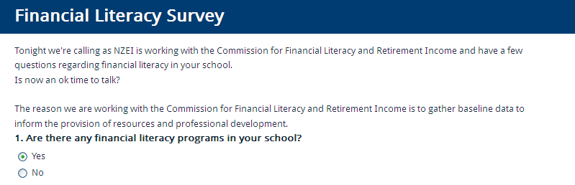

If the response was yes, the interviewer continued with the following questions.

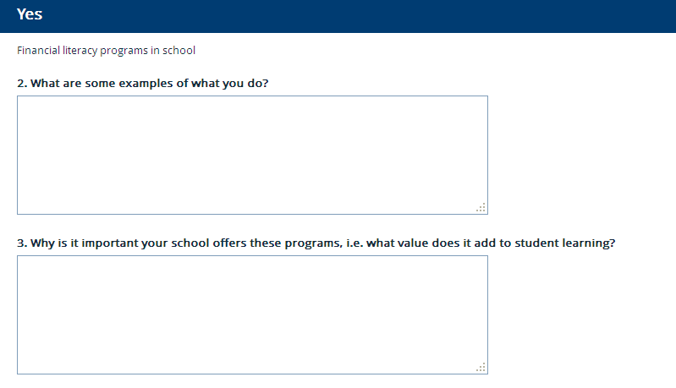

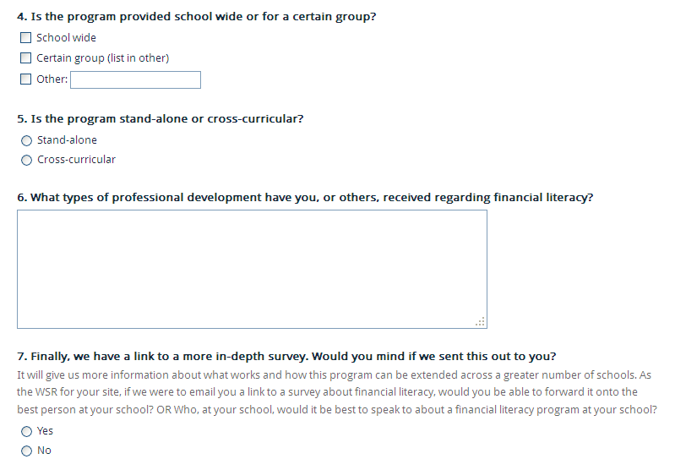

If the response to question 1 was no, the interviewer continued with the following questions.

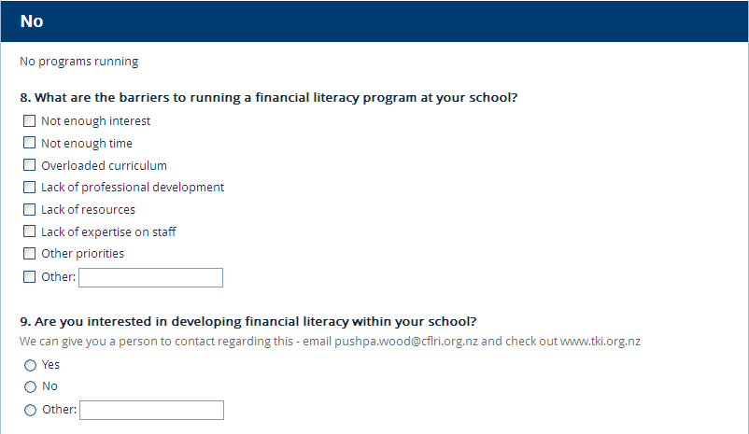

## In-depth survey

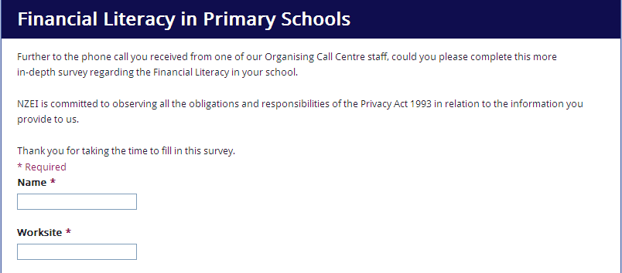

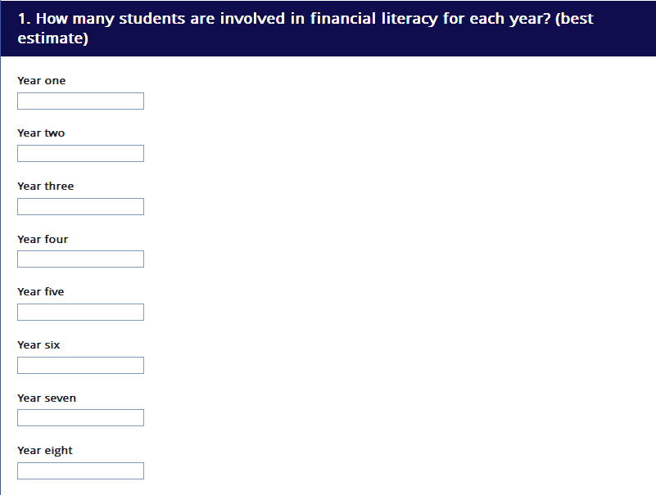

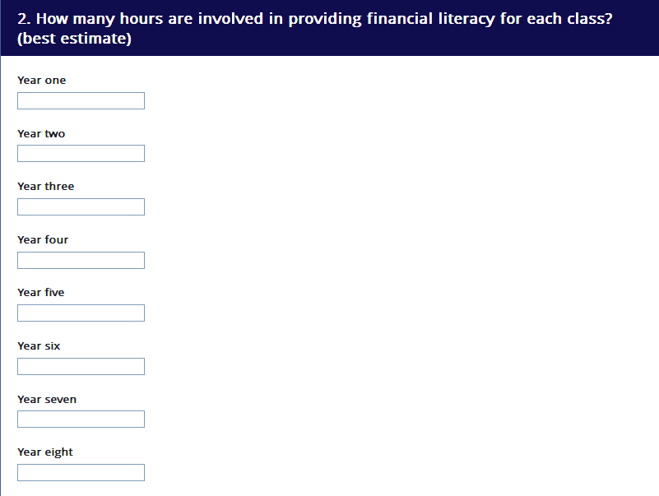

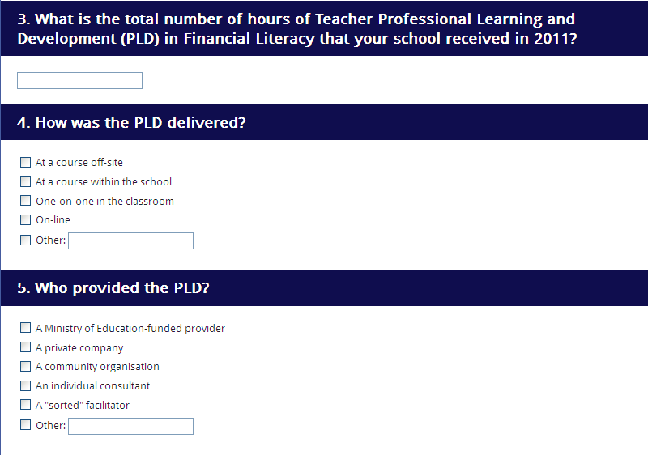

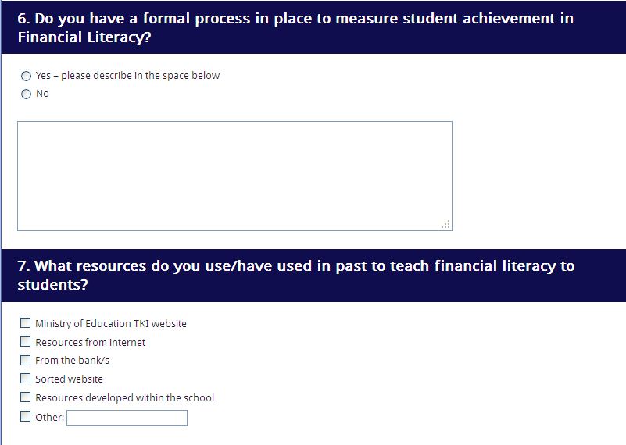

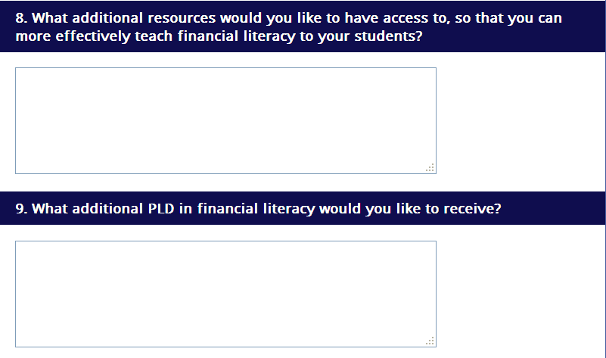

# 

# Telephone survey responses

|  |  |  |  |  |  |  |  |  |  |  |  |
| --- | --- | --- | --- | --- | --- | --- | --- | --- | --- | --- | --- |
| Are there any financial literacy programmes in your school? | If yes | | | | | | If no | | Decile | U-grade | Comments |
| What are some examples of what you do? | Why is it important your school offers these programmes, i.e. what value does it add to student learning? | Is the programme provided school wide or for a certain group? | Is the programme stand-alone or cross-curricular? | What types of professional development have you, or others, received regarding financial literacy? | Finally, we have a link to a more in-depth survey. Can we send this out to you? | What are the barriers to running a financial literacy programme at your school? | Are you interested in developing financial literacy within your school? |
| No |  |  |  |  |  |  | Not enough interest, not enough time, overloaded curriculum, other priorities | No | 5 | 7 | Member can’t see there being any space for such programmes with everything else |
| Yes | ASB Bank runs a programme in the school. They talk to some classes about banking etc. Every second year the school runs a MoE designed programme for more advanced students. | It is a very important real life thing that kids need to learn. | Certain group (list in other) | Stand-alone | Not specifically. It is all supportive of the teachers’ manual. | Yes |  |  | 8 | 6 |  |
| No |  |  |  |  |  |  | Not enough interest, not enough time, overloaded curriculum | Best to contact principal | 9 | 1 | At a small two-person school so the best person to contact would be the principal. |
| No |  |  |  |  |  |  | Not enough time, lack of professional development, lack of expertise on staff | No | 4 | 2 | Is busy working on developing maths, it's only primary. |
| No |  |  |  |  |  |  | Not enough time, overloaded curriculum | No | 1 | 5 | Not my place to talk about curriculum issues. Why would we teach that to five year olds? |
| No | *Figure It Out* financial literacy. |  |  |  |  |  | Not enough time | Yes | 6 | 6 | Kids involved in banking with (National bank? Not sure) - someone came around and gave a talk on financial literacy from this bank and was really helpful. Other than that, no financial literacy programmes. |
| No |  |  |  |  |  |  | Not enough time, lack of professional development, lack of expertise on staff | Yes | 9 | 4 |  |
| Yes | A teacher came in last year and ran an 'enquiry' programme with students as an exemplar topic. This led to the school setting up school banking with ASB. The teacher is not returning this year, but they are looking at someone else within the school to take up the role. | “Pretty self-explanatory isn't it?” | School wide | Stand-alone | The teacher who came in ran the programme; there was no additional PD for staff at the time. | No |  |  | 1 | 7 | Thought the survey was quite vague, but was happy to take part. Also was happier once it was explained why the commission and NZEI were doing the survey. |
| No |  |  |  |  |  |  | Overloaded curriculum | No | 1 | 4 |  |
| Yes | Using financial literacy *Figure It Out* books for older kids, also integrated it with maths programme.concept of enterprise – school-wide programme, run over a whole term.Had market day; each class had to create a product and sell it, competition to make the most money, doing surveys to get the best idea of products. Banking relationship – ASB people come around and talk to each class about banking and financial literacy. | Relevant to life; very important life skill. Teachers' job is creating futures; as a society, financial literacy is very important. | School wide | Cross-curricular | Numeracy programme developed over several years; this involves financial literacy but is not directly concerned with it. | Yes |  |  | 3 | 3 |  |
| Yes | *Figure It Out* books Doing a rotation – this term there's an English focus, next term there's a maths/financial literacy focus. | Kids get better opportunities in life, makes them more aware of money and its importance in life. | School wide | Stand-alone | Haven't had any yet. It is down for staff meeting so will happen eventually. | Yes |  |  | 10 | 6 |  |
| No |  |  |  |  |  |  | Overloaded curriculum | Yes | 2 | 4 |  |
| No |  |  |  |  |  |  | Not enough time, overloaded curriculum | No | 5 | 4 |  |
| Yes | Seniors do the lunches; they count and sort out the money, orders etc. | Prepares them for later life | Certain group (list in other) | Stand-alone | None | No |  |  | 8 | 2 |  |
| Yes | We use a lot of resources from ASB, particularly with year 6 students. Focus a term of work on financial literacy for year 6s. | We see it as a life skill. To a degree, disappointed it appears in social studies but not maths curriculum, as it is very closely linked to maths and works well when taught alongside. | Certain group (list in other) | Cross-curricular | The ASB provides a lot of PD and support if you adopt one of their programmes as our school has done. Also applying the 'number 8 wire', work as we go approach like a lot of NZ teachers. | Yes |  |  | 1 | 6 |  |
| No |  |  |  |  |  |  | Decile level; students need more numeracy before financial literacy is covered | No | 1 | 4 |  |
| Yes | Give the kids real-life examples of money matters for maths. Looking at coins, do maths problems with real money. Every 2nd year in maths a focus on financial literacy comes up for a period of time. | Real-life skills; kids have to go out and use money their whole lives. Lots of young people get into trouble with debt and credit cards. | School wide | Cross-curricular | None | Yes |  |  | 10 | 5 |  |
| No |  |  |  |  |  |  | Not enough interest, other priorities. | Yes | 1 | 4 |  |
| Yes | Hasn't started yet but we just signed up to one with ASB. | So that kids have experience with money and saving. | School wide | Cross-curricular |  | Yes |  |  | 5 | 5 |  |
| Yes | *Figure It Out* financial literacy maths books Years 5–6 and 7–8 run some kind of financial literacy programmes ASB banking programme Limited financial literacy in maths below year 5 | To ensure that children know how to save! | School wide | Cross-curricular | None | Yes |  |  | 7 | 5 |  |
| Yes | ASB bank stand-alone unit on financial literacy Alongside that, Figure It Out books. | Lets them understand money! Where it comes from, what you use it for, budgeting and planning. Life skills! | Certain group (list in other), just seniors. | Stand-alone | None | Yes |  |  | 5 | 4 |  |
| Yes | Group of year 5–6s entered futureintech engineering competition, came up with enviro-friendly shelter at school, had to research it, cost it, etc, then enter in competition.  Another group of year 5–6 children investigated, designed, budgeted and formally proposed (meet with principal, costing etc) for a skink garden.  Another group did a proposal on fixing flooding at school, same process as above.  School fair – kids producing their own goods like bath salts, artworks, marketing and selling these at fair.   Fundraising Guy Fawkes celebration every year, children are heavily involved in the child-friendly aspects like face painting. Involved in money side of it as well as actual activities.  Tropical fish tank, cost lots of money; every child in school is involved in collectively raising money to fund this. Kids don't just donate, they have to fundraise.  *Figure It Out* books  Children themselves brought a proposal to run a raffle for Christchurch. Had to put it through to the principal etc. Also kids set up a 'save the kiwi' booth in the playground and got sizeable donations. Both of these were child-initiated with little or no involvement, at least in their genesis, from staff. | Financial literacy is important part of being mathematically numerate. Also important part of literacy; lots of marketing and proposal and planning involved. And obviously children must be financially capable in life. | School wide, certain group (list in other) | Stand-alone | Nothing, beyond any PD for maths. | Yes |  |  | 10 | 5 |  |
| Yes | PrEP; an enterprise programme. School prints make-believe currency; taxes, banking involved. Ends with a big market day where they sell their products. | Life skills. Start learning about money in a make-believe way but they do have the opportunity to gain or lose, and they see the consequences of their actions from a financial perspective. Gets them used to it for when they actually use money. Also teaches them about essential financial functions like taxes, finer points of banking (deposits and withdrawals etc). | School wide | Cross-curricular | Staff meeting discussions about how the programme’s going to run. PrEP programme comes with a manual-type instructions, can customise to your school. | Yes |  |  | 4 | 4 |  |
| No |  |  |  |  |  |  | Not enough time | No | 4 | 4 |  |
| No |  |  |  |  |  |  | Other priorities | Yes | 10 | 7 |  |
| No |  |  |  |  |  |  | Not enough time, overloaded curriculum, Catholic school, lots of extra-curricular stuff | Yes | 6 | 4 |  |
| Yes | ASB one last year | Gave them an awareness of money, budgeting, banking – maths elements but mainly life skills. | School wide | Cross-curricular | None | Yes |  |  | 9 | 5 |  |
| No |  |  |  |  |  |  | Not enough interest, lack of expertise on staff | Yes | 5 | 8 |  |
| Yes | Just introduced it to our numeracy programme | Really important for young people because they'll need to know when they start work at an older age. | Certain group (list in other); is optional whether teachers wish to include it in their classes on numeracy | Cross-curricular | None | No |  |  | 6 | 5 |  |
| Yes | Introduced in junior school, developed in senior | Real world skills; something that children will have to deal with when they grow up. | School wide | Cross-curricular | None | Yes |  |  | 9 | 6 |  |
| No |  |  |  |  |  |  | Not enough time, lack of resources, lack of expertise on staff | Yes | 10 | 4 | Did have a one-off presentation last year for little kids. |
| No |  |  |  |  |  |  | Finance | Yes | 1 | 5 | Was previously funded for programmes by CPL |
| No |  |  |  |  |  |  | Not enough time, overloaded curriculum | No | 9 | 5 |  |
| No |  |  |  |  |  |  | Not enough time, overloaded curriculum, lack of resources | Yes | 10 | 6 |  |
| No |  |  |  |  |  |  | Not enough time, overloaded curriculum, lack of expertise on staff, type of children – not for the younger ones | No | 1 | 4 | School now also has year 7, this could have potential here. Will bring up financial literacy with principal and pass on information |
| No |  |  |  |  |  |  | Decile 2 school; don't read very well | No | 2 | 4 |  |
| No |  |  |  |  |  |  | Just not part of the curriculum | No | 3 | 4 |  |
| No |  |  |  |  |  |  | Not enough time, overloaded curriculum, lack of resources, lack of expertise on staff | Yes | 5 | 9 | ASB come in sporadically and run seminars/ classes for the children but isn't a complete programme. Would need another specialised teacher in order to have a financial literacy programme but it is a great idea. |
| Yes | Don’t know | Yes – to help them become more aware of the financial situation in their lives | School wide | Cross-curricular | Not too sure | No |  |  | 2 | 5 | It is important to have one to help them become more aware of the financial situation in their lives |
| No |  |  |  |  |  |  | Not sure | Yes | 5 | 2 |  |
| Yes | Incorporated as part of the maths programme – have money-based examples in the maths book. Unsure if there is anything specific lined up for later in the year. | (Personally) believes financial literacy was not that important in primary schools – more important to teach the basic maths skills so the children can use these at a later stage to manipulate money and learn more specific skills at intermediate and college. Also mentioned she is from a low decile school, so there is not always that much money to teach the children about/with. | School wide | Cross-curricular | Have received PD for maths, but nothing specific for financial literacy. | No |  |  | 1 | 5 |  |
| Yes | ASB stand-alone programme. Also *Figure It Out* books. | It helps them to find ways to save. | School wide | Stand-alone | A couple of years ago; re *Figure It Out* books. Not for her but for selected staff members. | Yes |  |  | 1 | 8 |  |
| Yes | A year or two ago they ran the ASB and *Figure It Out* programme. Children worked out the costs involved with having a pet, checking Trade Me for prices of accessories etc. | Works in well with maths and makes children aware of the real world cost of things. |  | Stand-alone | None, "learnt with the children" | Yes |  |  | 7 | 2 |  |
| No |  |  |  |  |  |  | Not something considered with under 10 year olds. | No | 10 | 5 |  |
| No |  |  |  |  |  |  | Not enough time, overloaded curriculum, lack of professional development | No | 10 | 5 |  |
| No |  |  |  |  |  |  | Other priorities, haven't heard much about it | Yes | 3 | 3 |  |
| No |  |  |  |  |  |  | Not enough time, overloaded curriculum, monetary | No | 2 | 6 |  |
| Yes | Years 7 and 8 students have a cooking class; the food they make in this class gets sold at lunchtime. The money they make in these classes go towards paying for their school camp | Have to know the value of money, really small school. Offer the years 7 and 8 some responsibility towards their own education. Makes the students understand the value of money. | Certain group (list in other) | Cross-curricular | Use a special teacher that comes in to run the programme | Yes |  |  | 3 | 1 |  |
| Yes | A man from ASB came in and taught a one-hour session – one session each for juniors, the middle school and seniors. This was last year though, unsure if it is happening again this year. | Children these days just see plastic cards being exchanged, so it's important to teach them the value of money. | School wide | Stand-alone | No – the man from ASB ran the programme, there was no PD for the staff as only a one-hour session. | No |  |  | 9 | 6 |  |
| No |  |  |  |  |  |  | Not enough time, overloaded curriculum, other priorities, national standards takes up too much time |  | 3 | 6 | Member thinks financial literacy programmes are a great idea but had not previously heard of them. Thinks the only barrier for schools is time. |
| Yes | ASB comes to school | Gives them a practical skill for the real world. | School wide | Stand-alone | No | Yes |  |  | 7 | 5 |  |
| Yes | *Figure It Out* books | They know how to handle money – important to teach kids about reality and money management especially in low decile school. | Certain group (list in other), senior school | Cross-curricular | None | Yes |  |  | 2 | 5 |  |
| Yes | Within the social studies curriculum – they look at the Consumer Guarantees Act and also look at different types of banking. | They are an intermediate school so are preparing the children for high school. Also, some of them may be getting part-time jobs so it is important for them to know. | School wide, but has a main focus for one year level. | Cross-curricular | No specific professional development but have received some under the social studies umbrella. | No |  |  | 9 | 8 |  |
| Yes | ASB scheme – they send a representative in to do a 30 minute lesson then the school follows up with banking scheme. | It teaches children the difference between wants and needs and the importance of saving. | Certain group (list in other) | Stand-alone | They just sit in while the ASB rep takes the lesson. In term 4 the whole school is doing an entrepreneurism topic and there have been some books purchased for staff in preparation for this. | Yes |  |  | 1 | 4 |  |
| Yes | ASB 45 min session, primary enterprise programme /social enterprise, financial literacy in maths and social studies | Real life. Most important maths these kids need to learn | School wide | Cross-curricular | PrEP people have come. | Yes |  |  | 8 | 6 |  |
| No |  |  |  |  |  |  | Not enough time | No | 1 | 6 |  |
| No |  |  |  |  |  |  | Not enough time, overloaded curriculum |  | 7 | 3 | Some teachers informally use financial literacy as part of maths. |
| Yes | Their school is an ASB banking school. The people from ASB come in and speak to the students about saving. Mainly speak to years 5–8. | Teaches children about money; where they can put it, what they can do with it, savings etc. Also teaches them a language to use regarding money and finances. | School wide | Stand-alone | Teachers haven't had any specific training, but since work with intermediate-aged children, they are pretty clued up on financial literacy.  ASB have a presenter to run their programmes within schools and he found the presenter lacked knowledge - he had to ask lots of questions to the presenter so that the information got to the students. They also passed this onto the presenter trainers at ASB so this is being looked into from there as well. | No |  |  | 3 | 5 |  |
| Yes | ASB programme – managing money. School has a place where kids to save money (to ASB). Use in maths – money is a measure. | To teach children how to manage and use money. Life skill | School wide | Cross-curricular | Part of maths | Yes |  |  | 1 | 6 |  |
| Yes | ASB scheme, WSR not a classroom teacher so not completely sure. |  |  |  |  | No |  |  | 5 | 4 |  |
| No |  |  |  |  |  |  | Not enough time, overloaded curriculum, lack of expertise on staff | No | 1 | 3 |  |
| No |  |  |  |  |  |  | Lack of professional development, lack of expertise on staff |  | 6 | 2 | Had personally chosen to do financial literacy with students a few years ago. Thinks it is a good idea but there would need to be a lot more training. |
| Yes | PrEP programme, children set up their own business, once a year. | Teaches children about everyday life. | Certain group (list in other) | Cross-curricular | Teachers get sent to PD for PrEP | Yes |  |  | 9 | 4 |  |
| Yes | Their school runs the PrEP programme with their senior students. They run this every three years and have a smaller programme for the in-between years –usually around finances for school camp. | Teaches students about budgeting, money and cents/sense. | Certain group (list in other), seniors in the school | Stand-alone | The teachers who run the programme have had training, but as she doesn't run the programme she hasn't had any PD herself. | No |  |  | 6 | 5 |  |
| No |  |  |  |  |  |  | Not enough time, Lack of expertise on staff | Yes | 6 | 4 |  |
| No |  |  |  |  |  |  | Not enough interest, not enough time. Also surveyed the parents at the school and they did not see it as a high priority – maths, writing, reading, sport took preference. | Are signing up to the ASB courses | 4 | 2 |  |
| No |  |  |  |  |  |  | Lack of expertise on staff | Unsure | 10 | 4 |  |
| Yes | The children have bank accounts and do their banking every Tuesday. | To be fair I haven't really thought about it. Life skills! The importance of saving. Also they have the opportunity of extending their maths. | School wide | Stand-alone | None | No |  |  | 10 | 5 |  |
| No |  |  |  |  |  |  | Not mentioned at all. | No | 10 | 5 |  |
| Yes | *Figure It Out* books, one term/year concentrate on financial literacy, budgeting etc. | Life skills, have to be able to manage money. Children nowadays really don't comprehend where money comes from, how much it costs to support a family etc. | Certain groups (list in other), year 5 and up | Cross-curricular | Probably only what we know as experienced adults. | Yes |  |  | 8 | 4 |  |
| Yes | Not sure – definitely use in the senior school, have heard them talk about it but don't know detail | Important that children understand money | Certain groups (list in other) | Stand-alone | Not that she knows | Yes |  |  | 5 | 5 |  |
| No |  |  |  |  |  |  | Not enough interest, not enough time, lack of resources | Yes | 1 | 1 | Had never heard of it being taught in schools |
| No |  |  |  |  |  |  | Overloaded curriculum, lack of professional development, lack of expertise on staff | Yes | 4 | 2 |  |
| No |  |  |  |  |  |  | Overloaded curriculum, lack of resources, lack of expertise on staff | No | 10 | 7 |  |
| No |  |  |  |  |  |  | Overloaded curriculum, lack of professional development, lack of resources | No | 1 | 3 |  |
| Yes | The ASB programme | Some parents aren't sure how to budget so it's good the ASB comes in to teach the children. Also it's a stepping stone for children to start to understand budgeting. | School wide | Stand-alone | No – the ASB people run the programme. | No |  |  | 3 | 6 |  |
| No |  |  |  |  |  |  | Lack of professional development, lack of resources | No | 5 | 3 | Have the *Figure It Out* maths books. Is one of those things that need to be broken into explicit target areas to build on kids’ knowledge. Have to search for the right resources. |
| No |  |  |  |  |  |  | Not enough interest, not enough time, lack of enthusiasm | No | 4 | 6 |  |
| No |  |  |  |  |  |  | Not enough time, overloaded curriculum | No | 1 | 5 | Could be possibly worked into the maths programme |
| Yes | ASB came in and ran their programme. | To teach children about savings, interest and different options with money. | School wide | Stand-alone | ASB ran the programme so no professional development. | No |  |  | 3 | 5 |  |
| Yes | Have financial literacy as part of the maths programme. Also have a business day for the senior students. | It's important for children to know about money. | School wide, certain group (list in other), stand -alone programme for the senior students | Cross-curricular | No professional development. | No |  |  | 10 | 5 |  |
| No |  |  |  |  |  |  | Not enough interest, not enough time, overloaded curriculum | No | 10 | 6 |  |
| Yes | Real world situations –teaching them about money, flatting, cost of living etc. | Builds awareness – especially in today’s economic climate. Also teaches kids about the cost of living. | Certain group (list in other), seniors – years 7 and 8 | Stand-alone | No external professional development but has had some in-house training re financial literacy. | No |  |  | 8 | 6 |  |
| No |  |  |  |  |  |  | Covered into the maths programme but the school doesn't have a focus on it. |  | 3 | 3 |  |
| No |  |  |  |  |  |  | Not enough interest, other priorities, hasn't been discussed at all | No | 1 | 4 | The have some *Figure It Out* books but no set class programmes. |
| No |  |  |  |  |  |  | Not enough time, small school so already have a high workload. | No | 8 | 3 |  |
| Yes | Set up a pretend shop with play money, they save up to buy things. Learn the history of money and what it is. Make their own pretend Eftpos cards. Use the virtual lunch cafe (online and study ladder) shops, play money, save up etc. in year 2. Budgets. Cross-curricular with reading and writing. | Teaches children how to handle finances when older. | School wide | Cross-curricular | No formal PD, but is very involved in the sector/NZEI and networking, so keeps very up to date with these sorts of things. | No |  |  | 8 | 4 |  |
| No |  |  |  |  |  |  | Overloaded curriculum | No | 4 | 4 |  |
| Yes | Enterprise programme – apply for jobs, get paid when they do, they have to pay for goods and services and rent, ads etc. Produce goods, sell them at market. | It helps with the enquiry learning; kids take it where they want. Teachers stepping back and kids taking control of real-world issues that will come up in their future. | School wide | Stand-alone | Two people; had a two-day course, and one has run the programme at another school before. | Yes |  |  | 5 | 4 |  |
| Yes | ASB comes in and works with children. | In the wider sense of practical maths, it’s important that children have some sort of grounding in being able to look after finances; part of everyday life. | School wide | Stand-alone | None | Yes |  |  | 7 | 5 |  |
| Yes | Banking officesrs that liaise with National Bank staff. | Real life; gives them literacy and numeracy in context. | School wide | Stand-alone | Nothing | No |  |  | 4 | 1 |  |
| Yes | Trade fair – involved children making things, advertising them and selling them at market day. | It does cover that part of the curriculum. | School wide | Stand-alone | None | Yes |  |  | 8 | 3 |  |
| No |  |  |  |  |  |  | Overloaded curriculum, never crossed their minds to have a financial literacy programme | Didn't think financial literacy was appropriate for primary level | 3 | 7 |  |
| No |  |  |  |  |  |  | Not enough interest, lack of resources, lack of expertise on staff | No | 8 | 4 |  |
| Yes | End of last year the bank came in and gave a presentation. Member did not sit in so unsure what they covered. | It is valuable and good for schools to do | School wide |  |  | No |  |  | 3 | 5 |  |
| Yes | ASB are coming in next term to run their programme. | There are quite a few adults who don't have financial knowledge and this causes a few problems. It also means that parents cannot pass on financial knowledge to their children so it is important for children to learn it. Additionally the economic climate is changing so the financial knowledge that adults have now may not be relevant for the next generation. | School wide | Stand-alone | None – ASB runs the programme. | No |  |  | 7 | 5 |  |
| No |  |  |  |  |  |  | Not enough time, the more they need to focus on maths and literacy, the less time there is for anything else. | No | 2 | 5 |  |
| No |  |  |  |  |  |  | Not enough interest, overloaded curriculum, lack of resources | No | 2 | 5 | Have a banking programme. |
| Yes | Units taught at individual teacher’s discretion (with approval). Invite bankers in to speak to students about investments etc. Also use *Figure It Out* booklets. | It is valuable, but only at certain stages e.g. year 7–8. | Certain group (list in other), year 7–8 |  | None | No |  |  | 8 | 4 |  |
| No |  |  |  |  |  |  | Not enough time, overloaded curriculum, have quite a bit on already | No | 7 | 6 |  |
| Yes | A couple of guys (the Duffy Twins) who came in and took a six-week programme on financial literacy with each class and establishing savings patterns. | As children grow they become more financially aware, and this would help them manage that. | School wide | Stand-alone | None | Yes |  |  | 10 | 9 |  |
| No |  |  |  |  |  |  | Not enough time | No | 2 | 5 |  |
| No |  |  |  |  |  |  | Not enough time, overloaded curriculum, other priorities, national standards takes up too much time | No | 10 | 5 |  |
| No |  |  |  |  |  |  | Not enough interest, haven't thought about it. | No | 6 | 2 |  |
| No |  |  |  |  |  |  | Not enough time, overloaded curriculum | No | 2 | 1 | Only in the maths programme and is an area NZ needs to look into a bit more |
| No |  |  |  |  |  |  | Lack of expertise on staff | Yes | 7 | 3 |  |
| No |  |  |  |  |  |  | Not enough time | No | 4 | 5 |  |
| Yes | ASB came in and ran their programme. | It's important for children to understand why they need to learn financial literacy, and it is also part of the maths curriculum. | School wide | Stand-alone | ASB ran the programme so no professional development. | No |  |  | 4 | 4 |  |
| No |  |  |  |  |  |  | Lack of professional development, lack of expertise on staff | No | 3 | 3 | Small part within the maths programme |
| No |  |  |  |  |  |  | Lack of expertise on staff | No | 3 |  | Really valuable sort of thing to do; ASB does come sometimes and that is curriculum wide. |
| Yes | Enterprise programme last year – starting up businesses, banking, doing jobs etc with fake money, market day at end to spend it all. | All-round learning, teaching skills in real-world contexts. Can put lots of different subjects to kids through the 'lens' of enterprise/financial literacy. | School wide | Cross-curricular | One teacher had a strength in financial literacy/enterprise and so they guided/developed the rest of the staff, no PD per se. | Yes |  |  | 10 | 2 |  |
| Yes | ASB runs their programme | Because maths programmes are taught very poorly. | School wide | Stand-alone | No professional development (though said he doesn't need it). | No |  |  | 9 | 6 |  |
| Yes | Someone came through (ASB) last year and did programme with students. | Bringing learning back into practicality, real-life skills. | School wide | Cross-curricular | No. | Yes |  |  | 5 | 5 |  |
| No |  |  |  |  |  |  | Lack of professional development, lack of expertise on staff | No | 7 | 5 | Teach children maths as per the national standard, maybe that should be added to the curriculum there |
| No |  |  |  |  |  |  | Not enough time, overloaded curriculum | Yes | 3 | 4 |  |
| No |  |  |  |  |  |  | Not enough time | Yes | 8 | 5 |  |
| Yes | ASB | Obvious to us that they need to start thinking about these things from a young age. It’s not so easy as teaching them to count coins any more | School wide | Stand-alone | None has been received | No |  |  | 4 | 4 |  |
| No |  |  |  |  |  |  | Not enough interest, other priorities | No | 7 | 4 |  |
| Yes | *Figure It Out* resources; integrated into maths programme. | Involves numeracy; important life skills. | School wide | Cross-curricular | No | Yes |  |  | 8 | 1 |  |
| Yes | Run in maths time – money focus, *Figure It Out* series, and financial literacy books used. ASB comes in as well –full school | So that children have a broad understanding of why money matters. Financial structure of NZ | Certain group (list in other) | Cross-curricular | Don’t believe so. | No |  |  | 9 | 4 |  |
| Yes | Enterprising – financial literacy  *Figure It Out* books as well | Students develop skills for the future | School wide | Cross-curricular | Not that she is aware of | Yes |  |  | 7 | 5 |  |
| No |  |  |  |  |  |  | Not enough time, overloaded curriculum, other priorities; it's not important in terms of what the community wants. | No | 6 | 2 |  |
| Yes | *Figure It Out* books, tied in with numeracy | Sets children up for the future (real-life skills). | School wide | Cross-curricular |  | No |  |  | 5 | 2 |  |
| No |  |  |  |  |  |  | Lack of expertise on staff, impact of advisers. Children at their school live in a remote rural area, and don't often get the opportunity to practise what they learn, i.e. community only has one local shop. | Yes | 10 | 1 |  |
| Yes | Maths – *Figure It Out* | Valuable to get children up and going in the classroom | School wide | Cross-curricular | Not as such | No |  |  | 7 | 5 | Always more money into programmes is good. Numeracy as well as literacy is a big focus for them – more training would be better to support children |
| Yes | ASB has run theirs with the middle school. Separate, more in-depth programme with seniors (years 7–8) called "Precious", ties into careers and life skills as they do budgeting, compound interest etc. Also *Figure It Out*, plus fundraising for gala. | Directly tied into maths and numeracy in middle school; preparing for careers and life ahead. | Certain group (list in other), one programme for years 5–6, one for years 7–8 | Stand-alone | No. | Yes |  |  | 7 | 3 |  |
| No |  |  |  |  |  |  | Not enough time, overloaded curriculum, lack of resources | No | 8 | 5 | Has seen in other schools, thinks is important |
| Yes | National Bank helped. Woman came out and was very engaging and talked to the kids about banking and saving. | Real life skills; money is important! Also supports numeracy. | School wide | Stand-alone | No | Yes |  |  | 10 | 2 |  |
| No |  |  |  |  |  |  | Lack of resources, Lack of expertise on staff | No | 7 | 2 | thinks is a worthwhile venture but not in the near future |
| No |  |  |  |  |  |  | Overloaded curriculum, Scheduling with other curriculum activities | No | 6 | 5 | Also thought it would be good to get financial literacy programmes for the teachers as well. |
| Yes | Financial literacy – *Figure It Out* | Redundant question – have to know how to look after their own finances –children think money grows on trees, still really egocentric | School wide | Cross-curricular | Not that is aware of | No |  |  | 5 | 1 |  |
| No |  |  |  |  |  |  | Lack of professional development, lack of resources, lack of expertise on staff, don't think anyone has even thought about it | No | 3 | 4 | Makes them aware of money – but not literate in the use of money. |
| Yes | Run an enterprise unit –children work out all the finances and run the business | Make them aware of the value of money | Certain group (list in other), years 5–8 | Cross-curricular |  | No |  |  | 2 | 3 |  |
| Yes | Coin recognition, then play shops (pretend cash register etc). Similar thing at Xmas time – recreate Xmas shopping with fake money. She only teaches juniors. Money is a whole separate strand in the curriculum and middle/senior school covers it too (obviously in more depth) | Teaches in a real-life context, and shows that learning has real-life applications. This prepares students for future life (financial responsibility) but also shows them the value of future learning (as financial literacy proves it has real-life benefits). | School wide | Cross-curricular | Some PD around numeracy project throughout school at the moment includes some financial literacy. | No |  |  | 7 | 5 |  |

1. Wood, P. (2012) . Financial literacy best learned at a young age. Interviewed by Thorpe, C. *Bay of Plenty Times*. 6 June 2012 4:00
2. Ministry of Education. (2007) *The New Zealand Curriculum. The School Curriculum Design and Review.* Wellington: Learning Media. page 39
3. An NZEI Worksite Representative is an elected NZEI member at a school who acts as a NZEI contact person.
4. http://www.financialliteracy.org.nz/education-resources/schools